Project Name |  | Confidentiality Level
XX Project |  | For Recipients’ Reference Only
Project ID | Version | Document Code
 | 2.0 | BP_Proc _PI _006

CMS Project User's Manual

DBMS 12

Copyright © DBMS 12, Co., Ltd.
. All Rights Reserved
Revision Record
Date | Revision Version | CR ID /Defect ID | Sec No. | Change Description | Author

Content
1. Build Environment 4
1.1. Development environment 4
1.2. Data source 4
2. Function Description 5
2.1. Function name 1 5
2.2. Function name 2 5

Build Environment

Development environment
Type | Tools and environment
Development tools | Myeclipse
Use of technology | Jsp,servlet,css,tomcat
Operating environment | Windows8.1

Data source
File data sources: description the storage format of file data.

Writing servlets implement each functions and call jsp which use css to show the website on the suppose of tomcat.

Function Description

Login
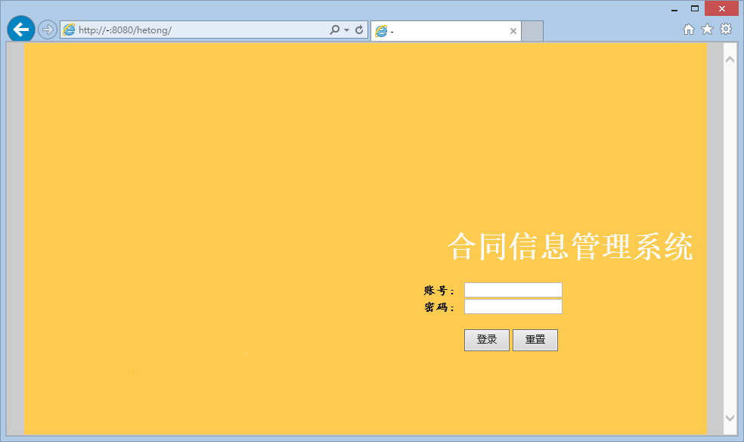
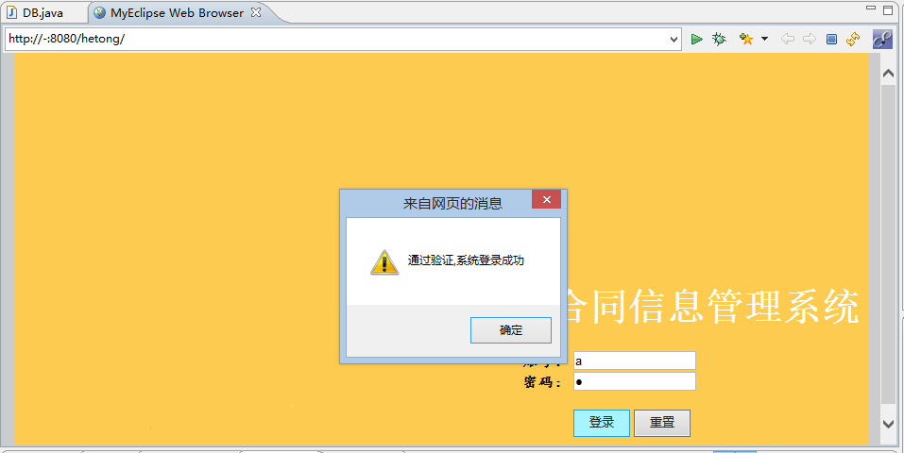
document | Login.jsp
In paraments | Username,password
Submit URL
Out parament | Session["username"]  Session["group"]
Function | login

Main Frame
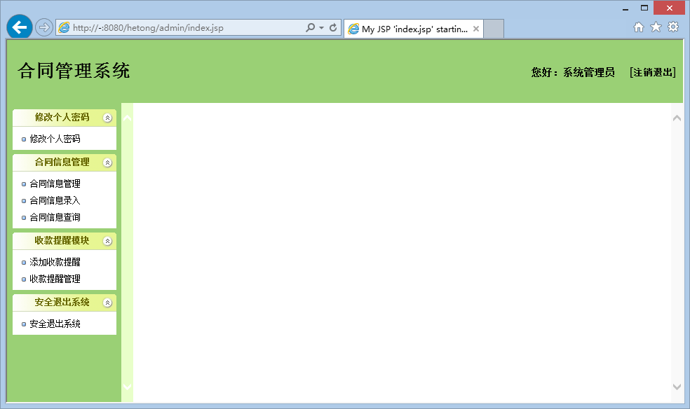

contract management model
2.3.1 contract manage
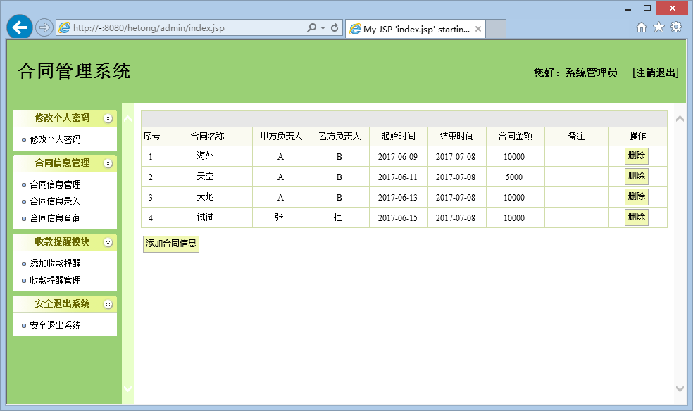

2.3.2 add contract

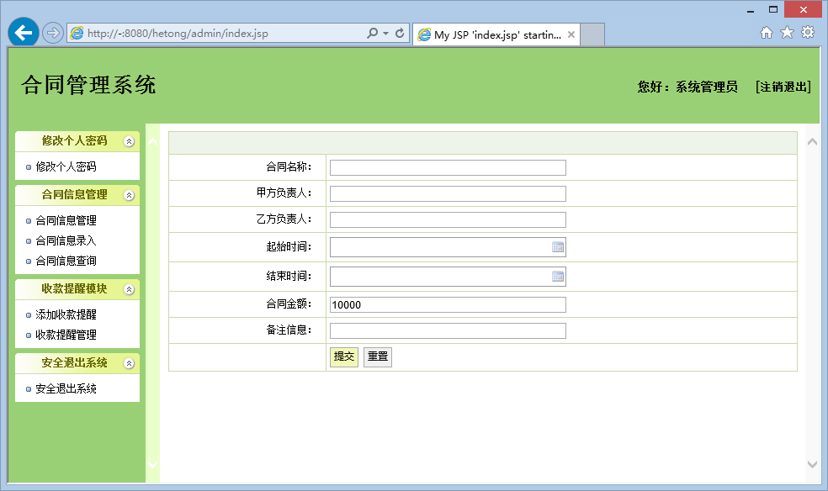

2.3.3 contract query

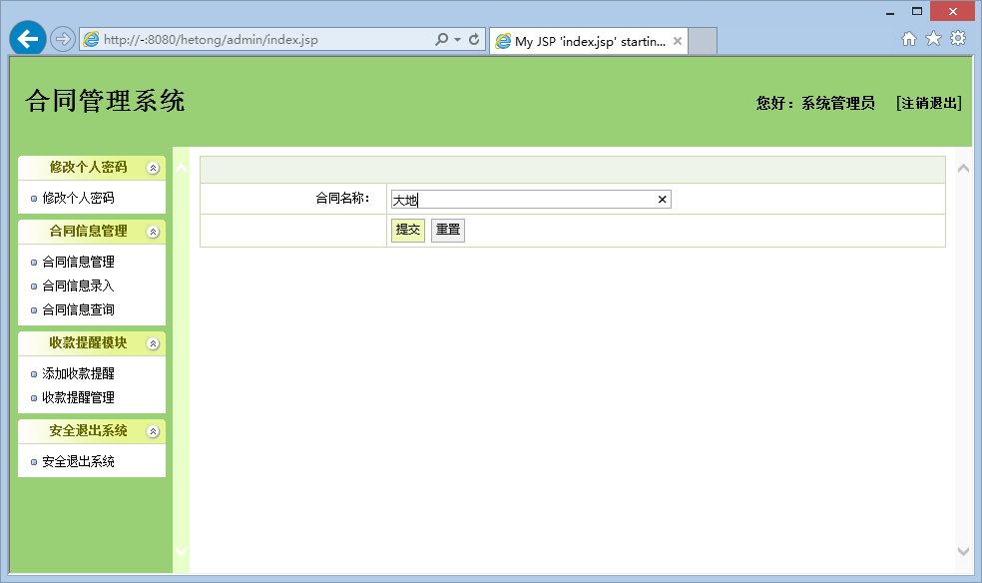
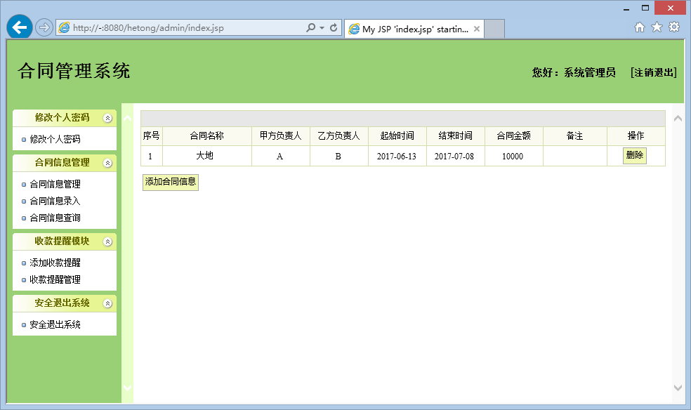

2.3.4 contract proceeds remind

